**Developing a Low-cost Autonomous Indoor Blimp**:

* An important navigation problem is automatic control of altitude and of horizonal movement. If blimp can be maintained at a specific altitude, it can be moved in a horizontal plane. They used PID and fuzzy logic controllers to control blimp altitude and evaluated the performance of the control systems developed using the controllers in two different environments.
* Another important navigation problem for blimps is obstacle detection and collision avoidance. They used ultrasonic sensor to measure the distance to potential obstacles and implemented a fuzzy logic controller to avoid collisions.
* Due to limitation on payload, onboard hardware could not be equipped with sensors to measure absolute vehicle position and this limited the autonomous navigation capabilities of the vehicle.

An ultrasonic, lightweight SRF05 sensor (with a resolution of 1 mm and a very narrow beam) was mounted facing downwards at the bottom of the gondola to measure the distance from the blimp to other objects. Sensor measurements were integrated by means of a Kalman filter which sequentially estimated blimp altitude. An altitude controller was implemented in the PC ground station using the distance measurements sent by the Wireless Communication Unit (WCU), with computed control signals sent back to the onboard microcontroller. The reference blimp altitude was specified in the program user interface, with the altitude control algorithm endeavoring to automatically maintain the blimp at this altitude. Controlling vertical motion reduced blimp movements by one degree of freedom.

*A. PID altitude controller:*

$$u_{PID}= K_{p}e\left(t\right)+ K_{i}\int_{0}^{t}{e\left(t\right)dt}+K_{d}\frac{de(t)}{dt}$$

Where $K_{p}, K_{i}$ and $K_{d}$ were parameters experimentally calculated using the Zieger-Nichols method and $u_{PID}$ was the command signal to the vertical propeller, responsible for up-and-down movements of the aerial vehicle.

The experiments have shown diverse results using the same controller in two environments. An overall good performance can be observed during the experiments carried out in environment 1. However, the same PID controller in environment 2 has shown an oscillating behavior with an important deviation from the mean. Although it can reach the altitude reference, there is a significant error.

*B. Fuzzy altitude controller:*

This controller uses fuzzy sets to model designer knowledge about the system to control, with knowledge representation modeled using fuzzy rules. This kind of controller has several advantages because it does not need to recalculate parameters when environmental conditions changes. The altitude fuzzy logic controller in our blimp had two inputs: altitude error and estimated current vertical speed. Altitude error was the difference between the desired altitude and current altitude. A change in altitude error indicated whether the aerial vehicle was approaching the reference altitude or moving away from it. The controller output was the vertical motor command.

After analyzing experimental results for the fuzzy altitude controller, the blimp showed only slight oscillations in both environments and deviations from the mean, were very small. A significant number of tests carried out in different circumstances led to similar good results in both environments.

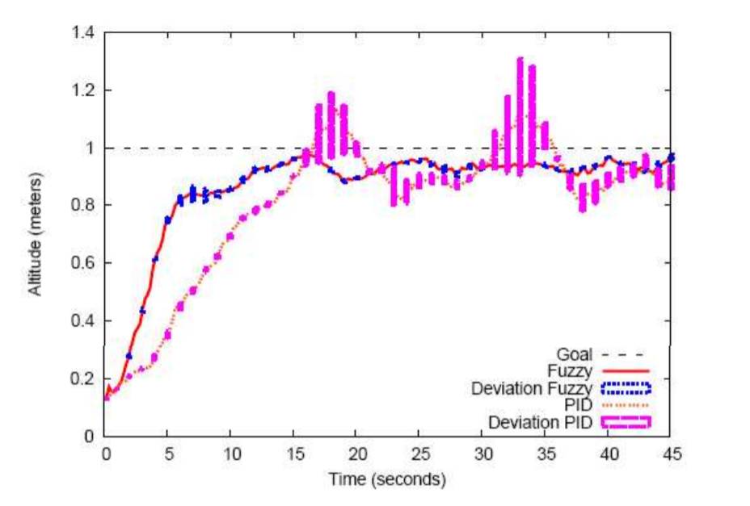

Comparative results show that the fuzzy logic controller produced balanced behavior in either of the two environments. The PID altitude controller performed slightly better than the fuzzy logic controller in environment 1, but its performance in environment 2 was significantly poorer than that of the fuzzy logic controller. A better PID controller in other environments would require online adjustment of PID parameters. Using a fuzzy logic controller, on the other hand, does not affect the behavior of the blimp too much and the controller parameters do not require modification.